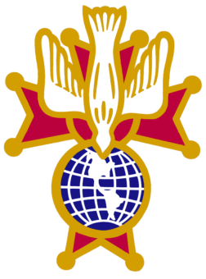  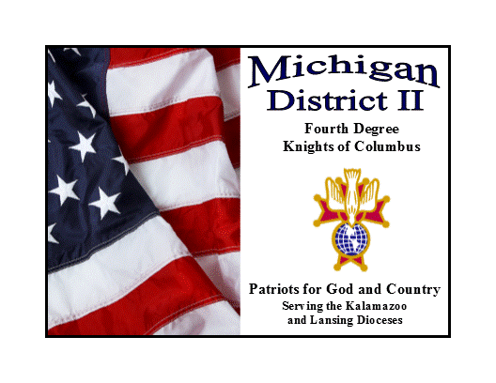  Michigan District II  Fourth Degree Knights of Columbus  Serving the Lansing & Kalamazoo Dioceses |  | 10572 Keane Dr.  Grass Lake, MI 49240  517-812-2620
Benedict Dandrow  Master of the Fourth Degree | FM David A. Buick  District Comptroller | SK William Currie  Senior Marshal

Sir Knight Registration Form
92nd Exemplification of the Fourth Degree
April 18, 2026 – Lansing, Michigan

Assembly _________________________________________________________ Name and Number

Name Sir Knight_________________________ Wife/Guest _________________
Last, First, MI First

Address_____________________________________________________________ Street, City, Zip Code
Phone _____________ _________________ __________________________
Home Cell Work

E-Mail_____________________________________________________________________

Costs
Master’s Banquet Tickets $40.00 each Number needed______ $___________

Total $ ___________
Please note any special dietary requirements:

__________________________________________________________________________

Checks are to be made out to your Assembly or Knights of Columbus

Men’s dress for the Exemplification is a dark business suit (black, dark blue, dark grey), plain white shirt, dark tie (no bow ties), black socks and black shoes, OR black tuxedo (traditional-no double breasted or tails), black bow tie, white pleated shirt (lay down collar-no winged tip collars allowed), black cummerbund (no vests), black shoes and socks.
Color Corps members are encouraged to wear their New Uniform.
Ladies dress in Church appropriate or semi-formal wear.

Registration Forms must be in to your Assembly before April 1, 2026

Late Registrations will be accepted on a space available basis and carry a $10.00 per person upcharge

