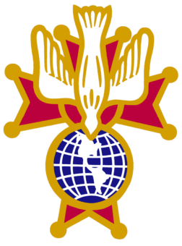  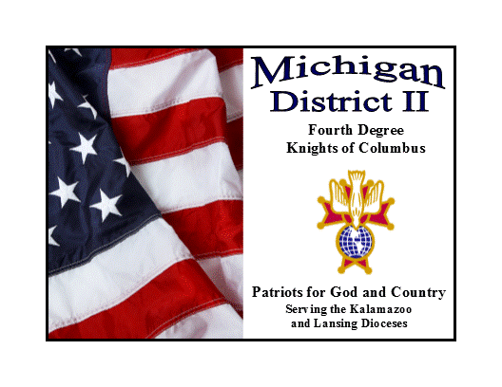  Michigan District II  Fourth Degree Knights of Columbus  Serving the Kalamazoo & Lansing Diocese |  | 10572 Keane Dr.  Grass Lake, MI 49240  517-812-2620
SK Benedict Dandrow  Master of the Fourth Degree | SK David A. Buick, FDM  Comptroller | SK William Currie  Senior Marshal

Candidate Registration Form
92nd Exemplification of the Patriotic 4th Degree
April 18, 2026 – Lansing, Michigan

New Assembly _______________________ Council _______________ Name and Number Number

Member Number _______________________________________________

Name Candidate ________________________ Wife/Guest ____________
Last, First, MI First

Address_______________________________________________________
Street, City, Zip Code

Phone ____________ ________________
Home Cell Work

E-Mail ________________________________________________________________

Please note any special dietary requirements here:

Costs
Candidate Fee $70.00 $ 70.00
(Includes Supreme Registration, Banquet, and Lapel pin)
Class Picture $10.00 each $ _____
Wife/Guest Banquet Tickets $40.00 each $ _____

Total $ _____

Checks are to be made out to your Assembly or Knights of Columbus
You will be required to dress in a dark business suit (black, dark blue, dark grey), plain white shirt – lay down collar (not button down), tie (no bow ties), black socks and black shoes.

Ladies should be in semi-formal wear.

All Form 4’s and Registration Forms must be into your Assembly before April 1, 2026.

